Ex.No:22: SIMULATION AND ANALYSIS OF BPSK MODULATION USING CONSTELLATION DIAGRAMS IN MATLAB
Objective 1:
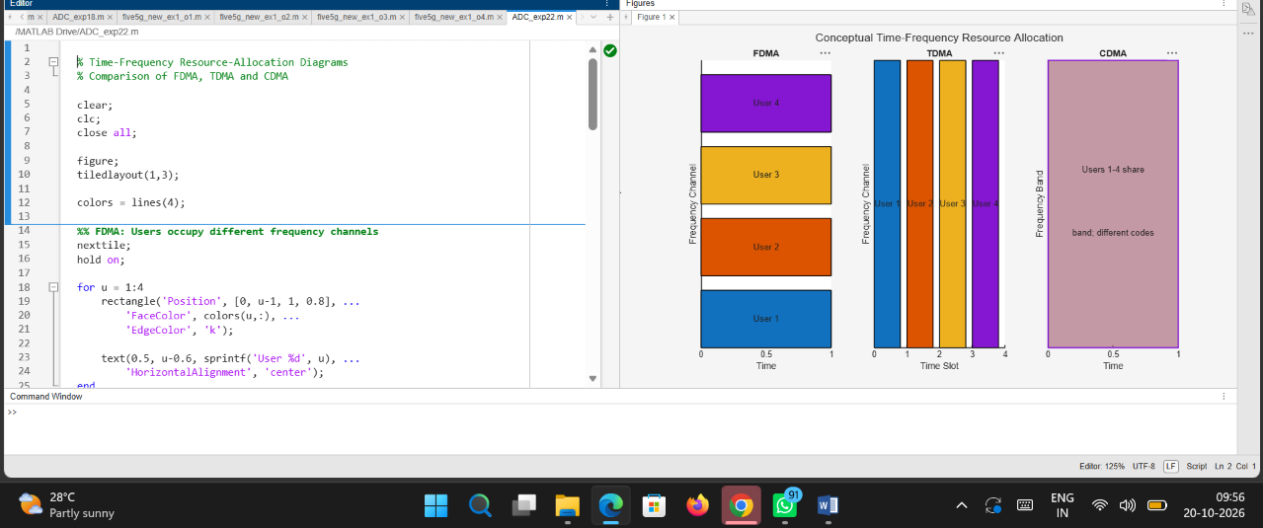
Code:
% Time-Frequency Resource-Allocation Diagrams
% Comparison of FDMA, TDMA and CDMA

clear;
clc;
close all;

figure;
tiledlayout(1,3);

colors = lines(4);

%% FDMA: Users occupy different frequency channels
nexttile;
hold on;

for u = 1:4
rectangle('Position', [0, u-1, 1, 0.8], ...
'FaceColor', colors(u,:), ...
'EdgeColor', 'k');

text(0.5, u-0.6, sprintf('User %d', u), ...
'HorizontalAlignment', 'center');
end

xlim([0 1]);
ylim([0 4]);
xlabel('Time');
ylabel('Frequency Channel');
title('FDMA');
set(gca, 'YTick', []);
hold off;

%% TDMA: Users occupy different time slots
nexttile;
hold on;

for u = 1:4
rectangle('Position', [u-1, 0, 0.8, 1], ...
'FaceColor', colors(u,:), ...
'EdgeColor', 'k');

text(u-0.6, 0.5, sprintf('User %d', u), ...
'HorizontalAlignment', 'center');
end

xlim([0 4]);
ylim([0 1]);
xlabel('Time Slot');
ylabel('Frequency Channel');
title('TDMA');
set(gca, 'YTick', []);
hold off;

%% CDMA: Users share the same time and frequency band
nexttile;
hold on;

for u = 1:4
rectangle('Position', [0, 0, 1, 1], ...
'FaceColor', colors(u,:), ...
'FaceAlpha', 0.22, ...
'EdgeColor', colors(u,:), ...
'LineWidth', 1.5);
end

text(0.5, 0.62, 'Users 1-4 share', ...
'HorizontalAlignment', 'center');

text(0.5, 0.40, 'band; different codes', ...
'HorizontalAlignment', 'center');

xlim([0 1]);
ylim([0 1]);
xlabel('Time');
ylabel('Frequency Band');
title('CDMA');
set(gca, 'YTick', []);
hold off;

%% Overall Figure Title
sgtitle('Conceptual Time-Frequency Resource Allocation');

Output:
